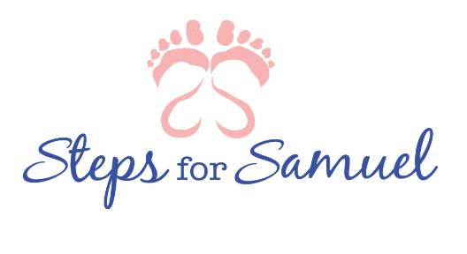
855 Lovers Lane Suite 107
270-599-4004
stespforsamuel@gmail.com

Date:___________________________

I would like to request:
A Comfort Kit for (select all that apply) :
Mom Father Sibling (age_________ sex__________)
Sibling (age_________sex___________)
Sibling (age_________sex___________)
Flowers for a memorial:
County of Memorial:_____________________________________________________________
Parent’s name:__________________________________________________________________
Initial loss Birthday Death Date Holiday Other______________
Date needed:_________________________________

Requesting individuals name, email and phone number: ______________________________________
__________________________________________________________________________________________________________________________________________________________________________
Your request CAN NOT be honored without this information. Please fill in completely. If you have not heard from us in 24 hours please contact us at the above information.

